Rethinking Small-Molecule Drug Discovery –
A Medicinal Chemist’s Perspective
Professor Billy Wai-Lung Ng (吳濰龍教授)
School of Pharmacy, Faculty of Medicine, The Chinese University of Hong Kong,
Hong Kong

Abstract:

Throughout history, nature has provided the foundation for many medicines. These natural solutions were later refined using rational drug design. Yet, a significant realm of potential treatments remains untapped, largely due to the limited diversity in our drug-screening libraries.

The Ng lab at the Faculty of Medicine, The Chinese University of Hong Kong, focuses on creating novel small molecules to tackle various human diseases. By integrating insights from both modern chemistry and biology, we are developing platforms to design more effective small-molecule therapeutics. A cornerstone of our strategy involves transforming readily available natural products, such as sugars, into intricate drug-screening libraries with rich information content. During this presentation, Prof. Ng will detail the recent endeavors using these versatile libraries for drug discovery, underscoring their potential in treating viral infections, cancers, and neurodegenerative diseases.

About Professor Billy Wai-Lung Ng:
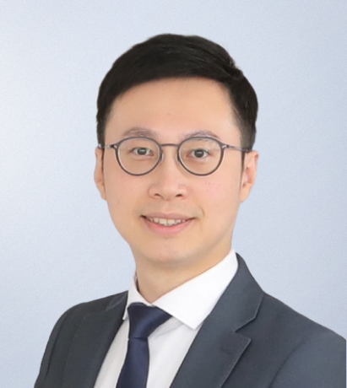
Professor Ng’s research interests are chemical biology, drug discovery, and medicinal chemistry. He obtained his B.Sc. degree in Chemistry (1st Class Hons.) and Ph.D. in Organic Chemistry from the Chinese University of Hong Kong. During his graduate study, he was a Fulbright Scholar at Massachusetts Institute of Technology (MIT), under the generous funding supports from the Lee Hysan Foundation and the Fulbright Program. From 2014 – 2016, he joined the University of Oxford as a Croucher Foundation Postdoctoral Fellow. He was then recruited to Harvard Medical School / Dana-Farber Cancer Institute as a research fellow from 2016 – 2019. He was honored as a Young Global Leader (2022) by the World Economic Forum. His research has been funded by diverse sources, including the Bill & Melinda Gates Foundation, US National Academy of Medicine (NAM), the Innovation and Technology Fund (ITF), and Research Grants Council (RGC) of Hong Kong.

